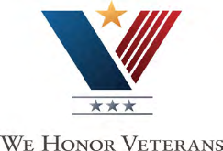
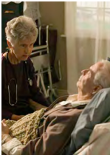
Lake Havasu City, Arizona
Home Health & Hospice
PH: 928-505-6473 Fax: 928-505-6474

Bullhead City, Arizona
Home Health
PH: 928-704-1302 Fax: 928-704-1308
Hospice
PH: 928-683-4041 Fax: 928-704-1306

Kingman, Arizona
Home Health
PH: 928-293-2352 Fax: 928-202-4646
Hospice
PH: 928-293-2353 Fax: 928-202-4646

Parker Arizona (Quartzsite, Salome & All of La Paz County)
Home Health
PH: 928-669-0010 Fax: 928-669-0070
Hospice
PH: 928-457-0100 Fax: 928-669-0070

Big River, California (Blythe-Needles)
Home Health
PH: 760-665-5255 Fax: 760-665-5259
Hospice
PH: 760-615-7451 Fax: 760-665-5259
Serving Those
Who Served Us

River Valley Hospice is dedicated to providing superior end-of-life care to all Veterans. All staff members are specifically trained to meet the unique needs of each Veteran and education training is regularly attended through our VA /Hospice Partnership.

River Valley Hospice strives to honor each Veteran at every opportunity. All Veterans receiving hospice services have the opportunity to be recognized through a “pinning ceremony”, which includes a branch specific certificate, VA/Hospice Partnership pin, a patriotic memorabilia item, and refreshments. All available staff members attend this ceremony and each Veteran is encouraged to invite friends and family.

Additionally, River Valley Hospice has implemented a Vet-to-Vet Volunteer Program.
This program allows Veteran patients to be paired with a volunteer who may have a better understanding of what the Veteran has experienced. Each Veteran is offered a Veteran Volunteer at admission.

Hospice Veteran Partnership

Ensuring Excellent Care for Our Nation’s Veterans

Veteran Volunteers may assist with:

•Providing companionship to Veteran patients.
– Playing card/board games
– Conversation
– Life Review
– Letter writing
– Light housekeeping
– And much more!

• Providing caregivers with a much needed break.

• Participating in Veteran pinning ceremonies

*Please note, Veteran Volunteers are not able to perform any hands-on care.
Please contact Rick Deno at 928-640-1007 for more information.

